Prob08 ATSC5011 Köhler Theory

Köhler theory describes saturation () over a haze particle and over a cloud droplet. Since haze particles and cloud droplets are curved, and since they form on aerosol particles containing water-soluble salts, two effects (curvature and solute) need to be accounted for. Köhler theory, or more specifically the Köhler equation, does that. Before starting this assignment, you should read pp. 1 – 6.

Assignment –

Consider two aerosol particles. They have different dry radii. We will assume that both dry particles contain pure sodium chloride. The temperature is 278.15 K.

1) Create the graphs shown below. Also, in the space below, paste your code that generates the Köhler curves for the two particles. What you should paste is just a few lines of code. Nothing else is required.



2) With pencil and paper (no IDL), evaluate the haze particle radii (there are two, one for the = 0.02 μm and one for the = 0.06 μm) at 0.99. For this calculation assume the curvature term is small relative to the solute term. In the space below, explain how you calculated the haze particle radii. Don’t forget to mention the approximation.

3) For = 0.02 μm, use IDL Newton to evaluate the haze particle radius at 0.99. Turn in your user-defined function and your code that calls the user-defined function though Newton. Are you using a “common block” to communicate the “state” information to the user-defined function? This can be accomplished in less than 20 lines of IDL code. Attach your code.

4) Generate the graph shown below. In a few sentences explain what you did.

**Derivation of the Köhler Equation**

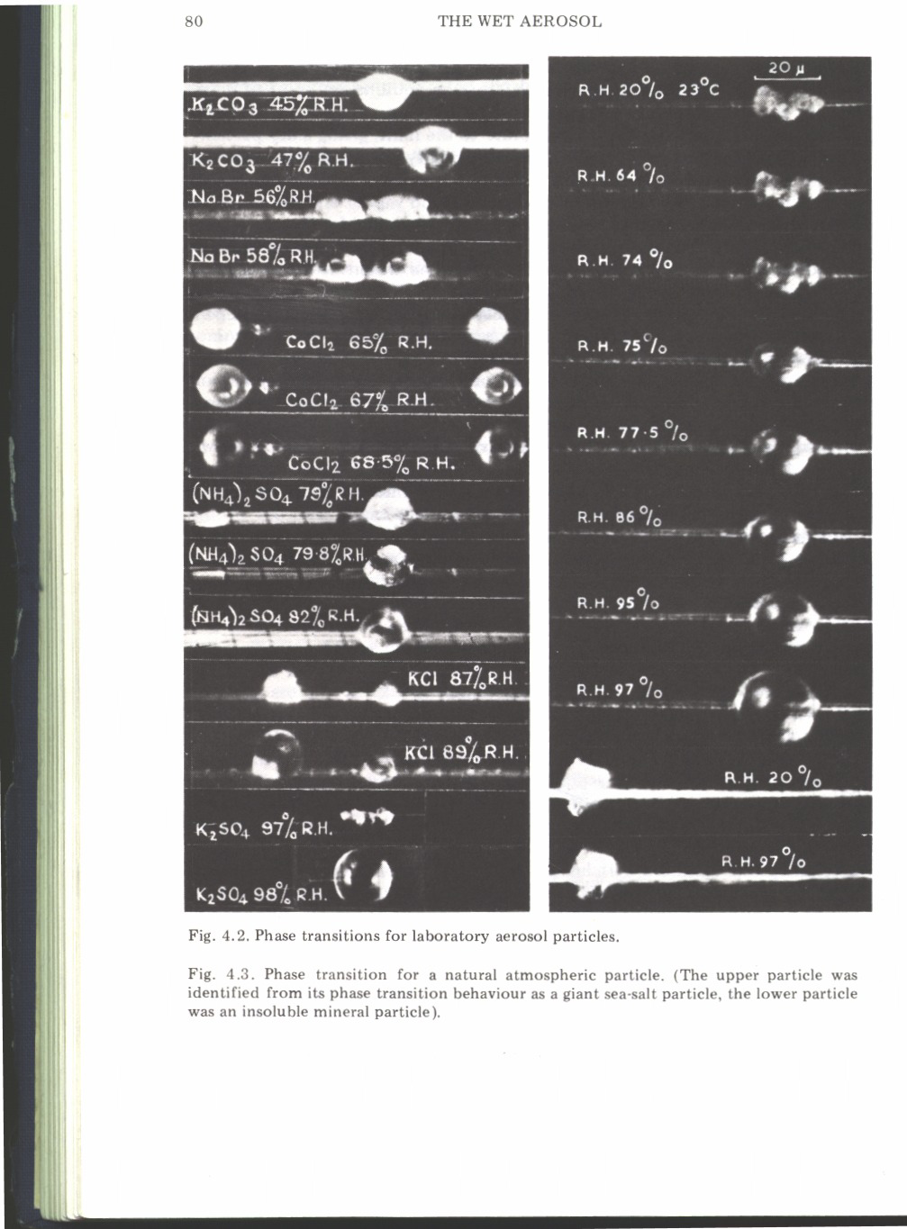

Consider a solution containing water and dissolved salt. At this point we are considering a bulk solution; i.e., something you can create in your kitchen by adding salt to a glass of water. By definition, a solution has two components. We will use the subscript “1” to indicate the solvent (water) and the subscript “2” to indicate salt.

Water activity () is defined as the ratio of the vapor pressure over a solution divided by the vapor pressure over pure water (i.e., ). According to Raoult’s Law, water activity can be expressed in terms of the mole amounts of water and salt ( and , respectively), and a vant Hoff factor ().

 (1)

Equation (1) arranges to Equation (2)

 (2)

Now consider an aerosol particle that is spherical and composed of pure sodium chloride. If the particle is exposed to water vapor the particle deliquesces and becomes a haze particle. Assume that all the salt is dissolved and the water and salt contribute to the volume of the haze particle as if the components were separate. The mole amount of water within the haze particle is

 (3)

Here  is the radius of the dry salt particle,  is molecular weight of water, and  is the radius of the haze particle. The mole amount of salt in the haze particle is

 (4)

Combining (2), (3) and (4), the water activity can be described in terms of the vant Hoff factor, the two radii (*r* and *rd*), and pure-component properties

 (5)

Assuming the second term in the denominator of Equation 5 is small relative one, and making a Taylor series expansion, Equation (5) simplifies to Equation (6)

 (6)

Water vapor saturation over a haze particle, or over a cloud droplet, can be approximated as the product of water activity and the Kelvin effect. For the latter we assume that the vapor-liquid surface energy () is not altered by the presence of salt. With these assumptions,  becomes

 (7)

For most atmospheric applications, the Kelvin term can be linearized. In that limit the water vapor saturation is

 (8)

After multiplying out the two terms on the right side of Equation (8), and examining the result, we see that one of the four terms is small in comparison to the other three. Neglecting that smallest term, the right side of Equation (8) becomes

 (9)

Also, in Equation 9, if we neglect  relative to the , we get Equation 10

 (10)

Finally, we define two parameters  and . We see that the latter is proportional to the amount of salt (cf. Equation 4). With these definitions the Köhler Equation becomes

 (11)

The Köhler Equation describes saturation over both a haze particle and over a cloud droplet. With a definition we are using in ATSC5011 (ambient saturation =), we distinguish between a haze particle and cloud droplet in the following way:



Haze Particle

“Unactivated”



Cloud Droplet

“Activated”

Note: In an upcoming lecture, we will see that is time-dependent. The time-dependent theory we develop has *S* increasing to a maximum, with *S* slightly greater than one, a few tens of meters above the lifted condensation level.

We note that there are three terms on the rhs of the Köhler Equation (Equation 11). The second is the curvature term, this enhances saturation for the same reason it enhances saturation over a curved surface of pure water (Kelvin effect). The third is the solute term. This lowers the saturation for the same reason that the presence of solute lowers the vapor pressure over a flat solution.