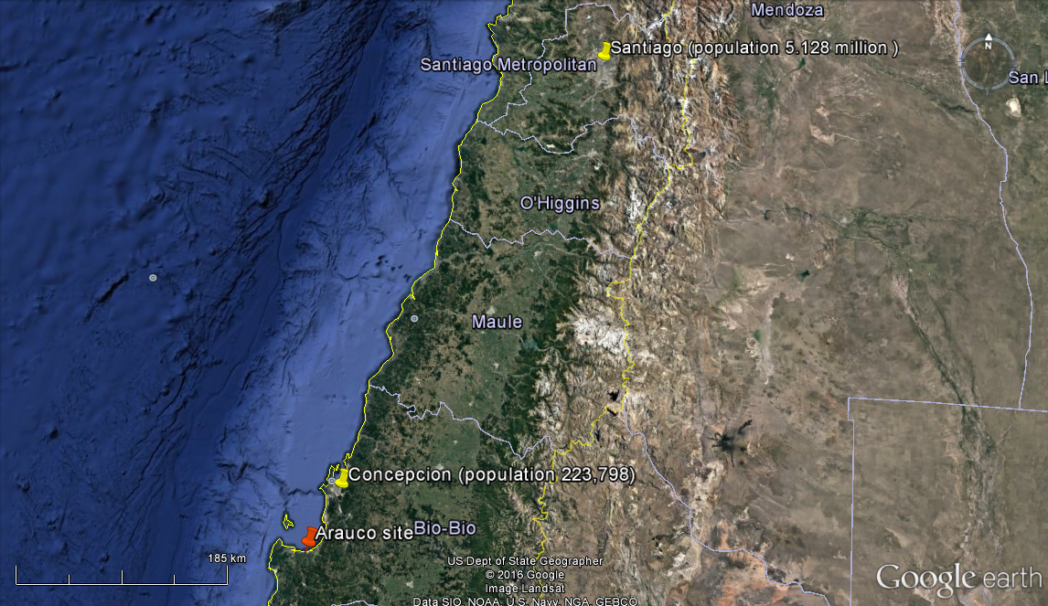

a

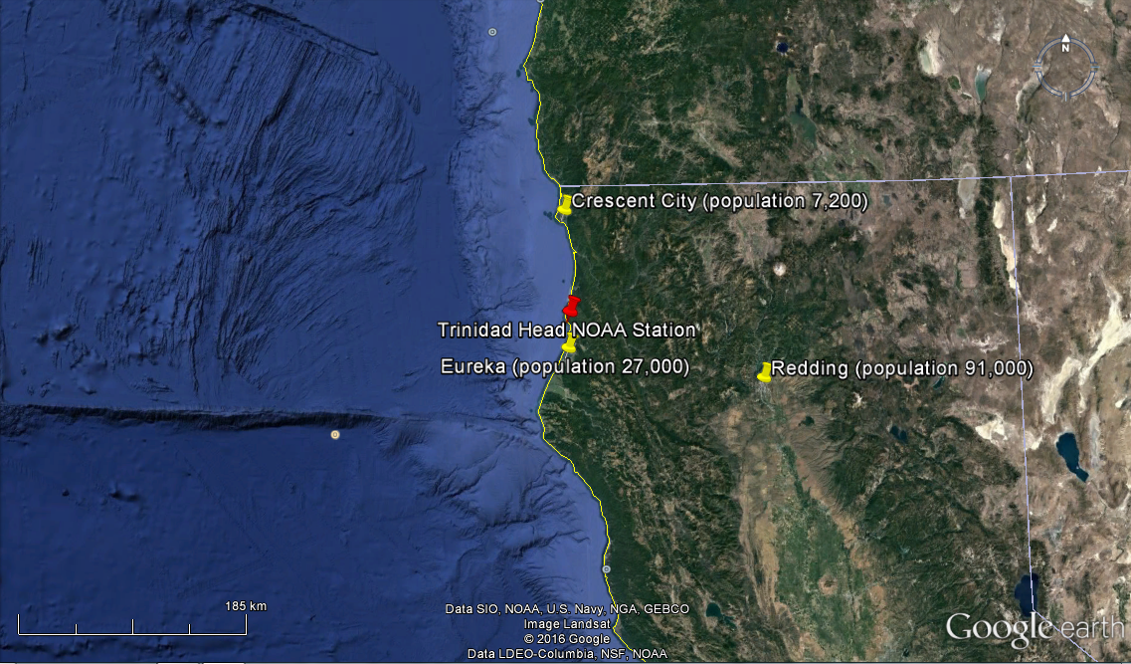

b

1. Arauco site, denoted by the red pin. The yellow pins denote major metropolitan areas. b) THD station, CA.



Clean sectors for Arauco (left, 160° to 290°) and THD (right, 250° to 20°).



HYSPLIT trajectory arriving at Arauco on 9 June 0 UTC. Bracket in right altitude panel denotes six-hour window used for wind speed calculation.

N vs *V* ratios for marine trajectories

|  |  |  |  |  |
| --- | --- | --- | --- | --- |
| Trajectory Arrival Time  Day, Month, Time (UTC) | N vs *V*  D > 0.055 μm  Ratio, μm-3 | N vs *V*  D > 0.055 μm  *r a* | N vs *V*  D > 0.12 μm  Ratio, μm-3 | N vs *V*  D > 0.12 μm  *r a* |
| 5 June 0 | 288 ± 4 | 0.92 | 132 ± 2 | 0.93 |
| 5 June 6 | 93 ± 4 | 0.54 | 60 ± 2 | 0.74 |
| 5 June 12 | 176 ± 12 | 0.79 | 87 ± 6 | 0.81 |
| 5 June 18 | 110 ± 3 | 0.66 | 64 ± 2 | 0.76 |
| 6 June 0 | 298 ± 13 | 0.81 | 113 ± 4 | 0.84 |
| 6 June 6 | 60 ± 1 | 0.53 | 34 ± 0.4 | 0.67 |
| 6 June 12 | 91 ± 4 | 0.60 | 44 ± 1.3 | 0.77 |
| 6 June 18 | 107 ± 4 | 0.33 | 42 ± 0.9 | 0.61 |
| 7 June 0 | 173 ± 13 | 0.35 | 68 ± 4 | 0.55 |
| 7 June 6 | 426 ± 6 | 0.92 | 177 ± 2 | 0.94 |
| 8 June 6 | 164 ± 9 | 0.06 | 89 ± 3 | 0.72 |
| 8 June 12 | 358 ± 11 | 0.75 | 139 ± 4 | 0.79 |
| 8 June 18 | 450 ± 9 | 0.88 | 202 ± 3 | 0.92 |
| 9 June 0 | 51 ± 4 | 0.55 | 31 ± 2 | 0.81 |
| 9 June 6 | 703 ± 19 | 0.68 | 228 ± 7 | 0.58 |
| 9 June 12 | 191 ± 19 | 0.75 | 101 ±5 | 0.95 |
| 9 June 18 | 675 ± 11 | 0.78 | 257 ± 3 | 0.89 |
| 10 June 0 | 519 ± 28 | 0.37 | 204 ± 7 | 0.83 |
| 10 June 6 | 857 ± 7 | 0.96 | 323 ± 3 | 0.96 |
| 10 June 18 | 825 ± 9 | 0.86 | 279 ± 3 | 0.91 |
| 11 June 0 | 171 ± 11 | 0.78 | 104 ± 5 | 0.89 |
| 11 June 6 | 78 ± 5 | 0.86 | 36 ± 2 | 0.88 |
| Average ( $\overline{x}± σ)$ | 312 ± 251 |  | 128 ± 85 |  |

*F* on *S* regressions, <*S>, <F>,* and<*V*>

|  |  |  |  |  |  |  |
| --- | --- | --- | --- | --- | --- | --- |
| Trajectory Arrival Time  Day, Month, Time (UTC)  (subinterval) | Slope  μm-2 cm3 | Y - Intercept | *r* a | <*S*>  μm2 cm-3 | <*F*> | <*V*>  µm3 cm-3 |
| 5 June 0 | -0.0027 | 0.75 | -0.84 | 79 | 0.54 | 3.59 |
| 5 June 6 | -0.0073 | 0.54 | -0.48 | 19 | 0.40 | 1.22 |
| 5 June 12 (11:00 – 11:34) | -0.0045 | 0.89 | -0.28 | 20 | 0.80 | 1.55 |
| 5 June 18 | -0.0043 | 0.75 | -0.49 | 44 | 0.56 | 2.85 |
| 6 June 0 | -0.0033 | 0.71 | -0.75 | 54 | 0.53 | 2.69 |
| 6 June 6 | -0.0046 | 0.93 | -0.69 | 23 | 0.83 | 1.82 |
| 6 June 12 | -0.0059 | 0.95 | -0.86 | 18 | 0.85 | 1.30 |
| 6 June 18 | -0.0049 | 0.94 | -0.67 | 24 | 0.82 | 1.72 |
| 7 June 0 (23:00 – 23:20) | -0.0020 | 0.72 | -0.77 | 46 | 0.63 | 2.22 |
| 7 June 6 | -0.0018 | 0.71 | -0.70 | 98 | 0.54 | 3.78 |
| 8 June 6 | -0.0031 | 0.78 | -0.82 | 36 | 0.67 | 1.76 |
| 8 June 12 | -0.0097 | 0.90 | -0.85 | 16 | 0.74 | 0.71 |
| 8 June 18 | -0.0016 | 0.73 | -0.74 | 82 | 0.60 | 2.93 |
| 9 June 0 (00:20 – 00:33) | -0.0073 | 0.88 | -0.94 | 29 | 0.67 | 0.94 |
| 9 June 6 | -0.0129 | 0.92 | -0.94 | 10 | 0.79 | 0.34 |
| 9 June 12 | -0.0006 | 0.61 | -0.63 | 38 | 0.58 | 1.14 |
| 9 June 18 | -0.0023 | 0.79 | -0.60 | 83 | 0.61 | 2.48 |
| 10 June 0 | -0.0025 | 0.75 | -0.26 | 24 | 0.69 | 0.71 |
| 10 June 6 | -0.0038 | 0.87 | -0.94 | 63 | 0.63 | 1.68 |
| 10 June 18 | -0.0018 | 0.81 | -0.50 | 12 | 0.61 | 3.07 |
| 11 June 0 (00:06 – 00:31) | -0.0017 | 0.64 | -0.88 | 68 | 0.52 | 1.79 |
| 11 June 6 | -0.0008 | 0.64 | -0.80 | 55 | 0.60 | 3.59 |
| Average ( $\overline{x}± σ)$ | -0.0041 ± 0.0030 | 0.78 ± 0.12 |  | 43 ± 26 | 0.65 ± 0.12 | 1.99 ± 1.01 |

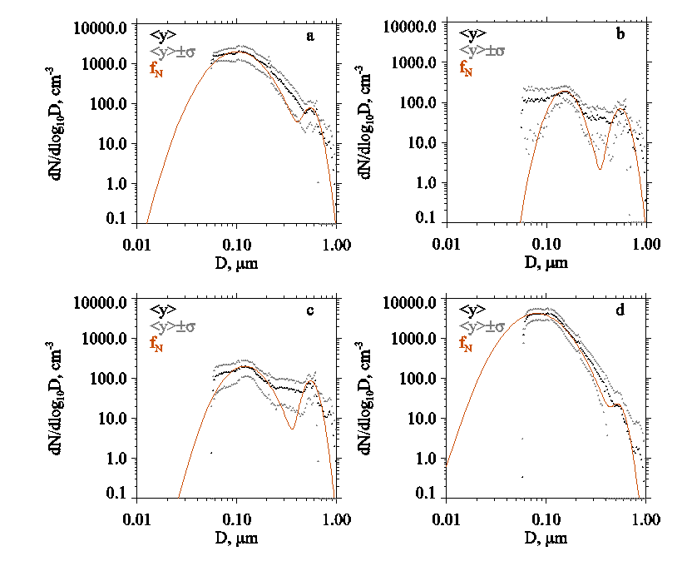

Two-hour averaged ASDs and bi-mode lognormal fit functions. a) 5 June 0 UTC arrival; b) 5 June 12 UTC arrival; c) 6 June 6 UTC arrival; d) 9 June 18 UTC arrival.



ND>0.5 vs sea-surface wind speed. The exponential fit is adapted from LS04.