Coarse Particle and Ice Crystal Concentrations in the Northern
and Southern Subtropical Middle Troposphere

J.R.Snider¹, D.Zhang¹, Z.Wang¹, D.Leon¹, G.Sever¹ and P.Field²
¹ University of Wyoming, Dept. of Atmospheric Science, US
² Met Office, Exeter, UK

Funding: NSF Physical and Dynamic Meteorology

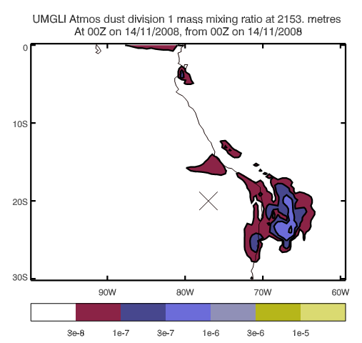

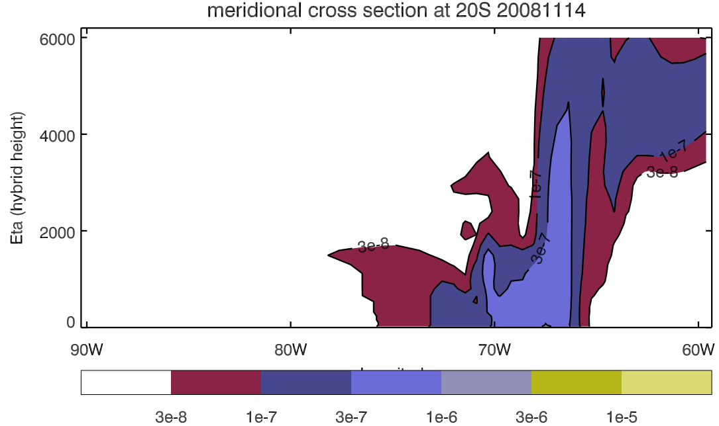

Thanks- Jane Mulcahy (Met Office)

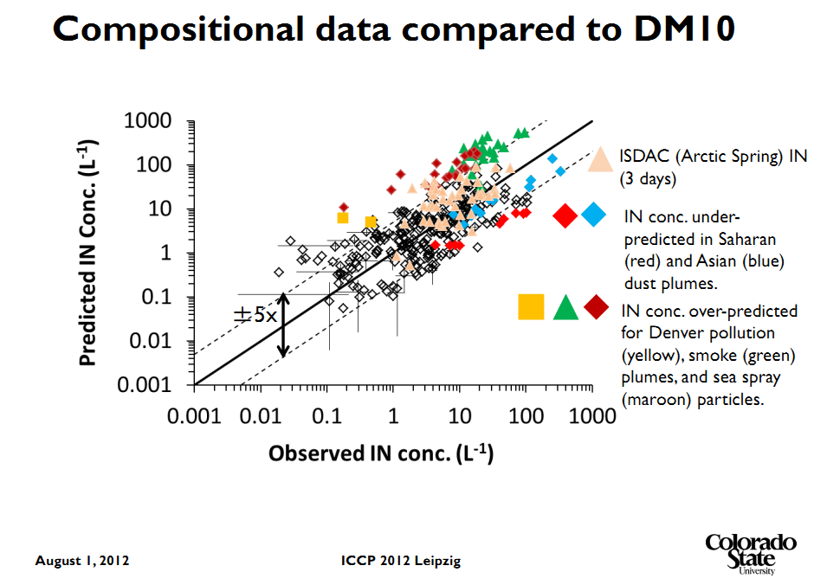

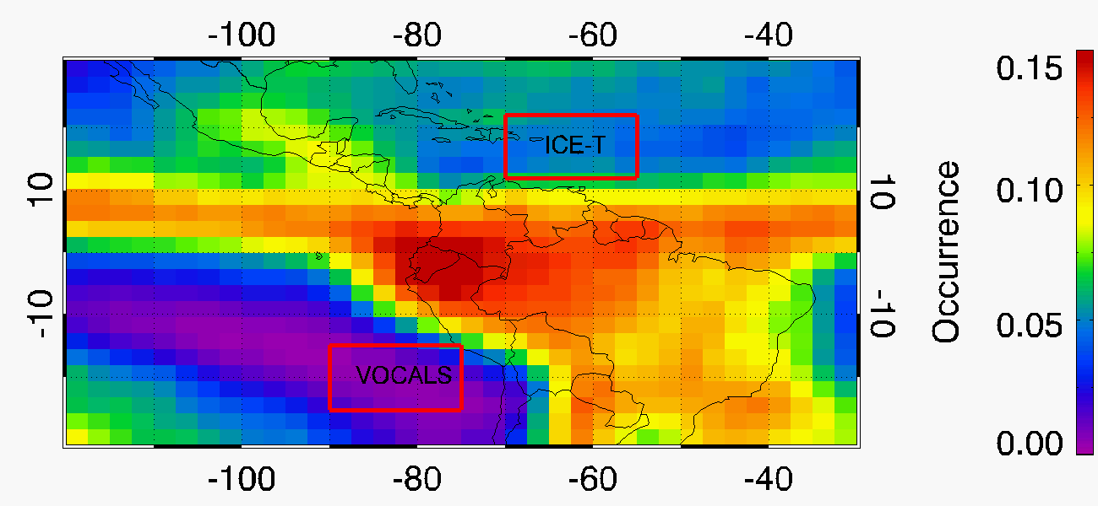

Occurrence of midlevel liquid-layer-topped stratiform clouds (MLTSC)
October, November, December (VOCALS)
June, July, August (ICET)
2006, 2007, 2008, 2009, 2010 CloudSat/CALIPSO measurements

zhang_iccp_2012.pdf

$Z_{e,1}$ $Z_{e,2}$
$N_{\text{XT},1}$ $N_{\text{XT},2}$
zhang_jgr_2010.pdf

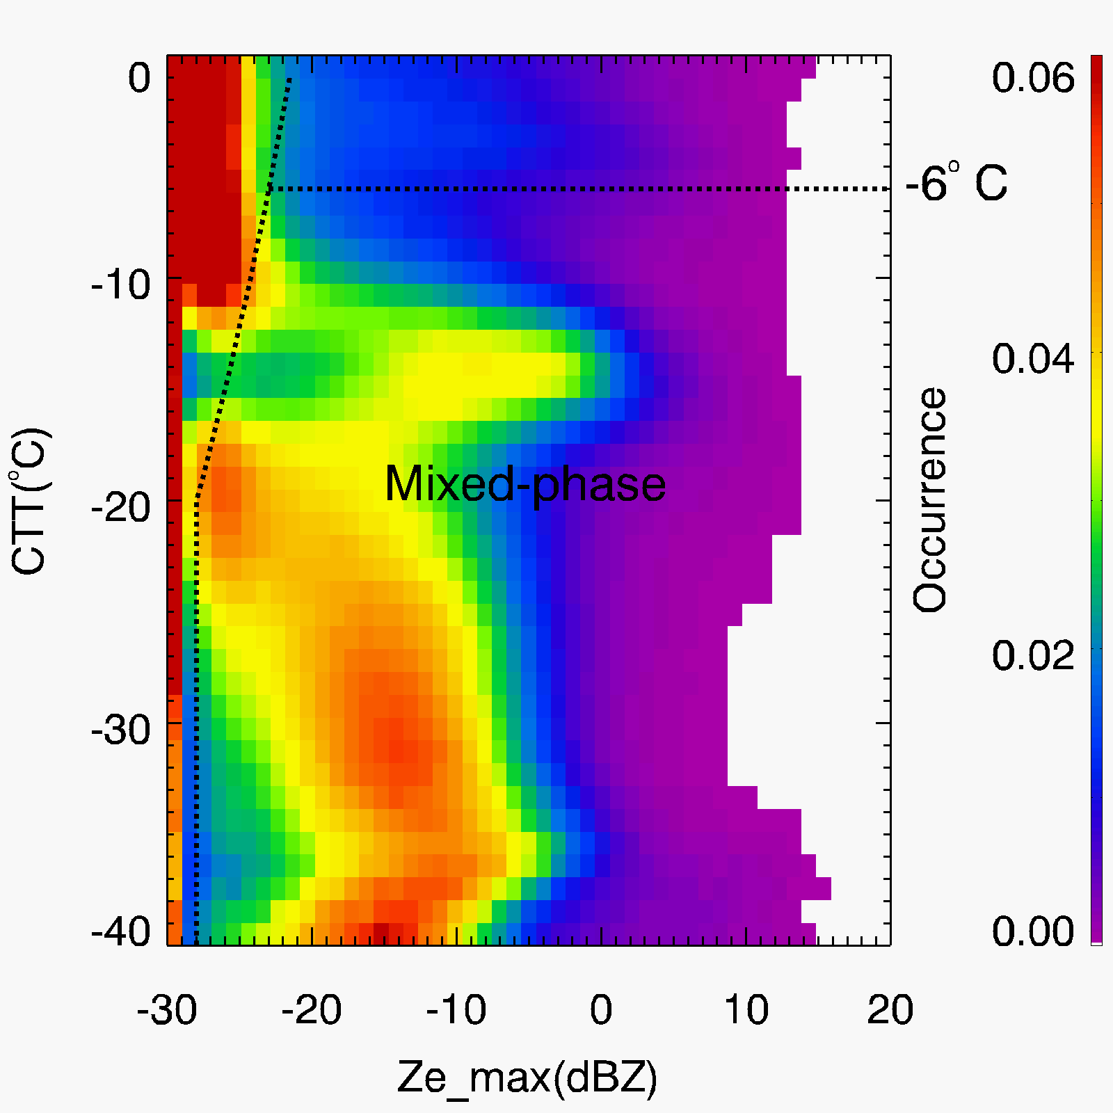

Wing-mounted Coarse Aerosol Instruments - VOCALS and ICET
Name | Full Name | Aerosol  Sample Rate | Size Range
PCASP | Passive Cavity Aerosol Spectrometer Probe | 1 cm⁻³ s⁻¹ | 0.12 μm <D<3 μm
FSSP-300 | Forward Scattering Spectrometer Probe | 17 cm⁻³ s⁻¹ | 0.4 μm <D<20 μm
CPSD  (ICET only) | Cloud and Aerosol Spectrometer - Depolarization | 20 cm⁻³ s⁻¹ | 1.0 μm <D<50 μm
CDP | Cloud Droplet Probe | 24 cm⁻³ s⁻¹ | 2 μm <D<50 μm

